Customer Engagement & Product Utilization Analytics for Retention Strategy
1. Introduction
Customer retention is one of the most critical challenges faced by banks and financial institutions. Acquiring new customers is often more expensive than retaining existing ones. Therefore, understanding customer engagement patterns and product utilization behaviour is essential for reducing customer churn and improving long-term profitability.
This project focuses on analysing customer engagement, product ownership, and financial commitment factors to identify customers at risk of churn and provide data-driven retention strategies.
2. Problem Statement
Banks face significant losses when customers discontinue their services. Customer churn can occur due to low engagement, limited product usage, dissatisfaction, or lack of personalized services.
The objective of this project is to identify the factors influencing customer churn and recommend strategies that improve customer retention through engagement enhancement and product utilization optimization.

3. Project Objectives

(a) Primary Objectives
- Evaluate the relationship between customer engagement and churn.
- Measure the impact of product ownership on customer retention.
- Identify disengaged high-value customers.
- Analyse churn patterns across different customer segments.

(b) Secondary Objectives
- Support engagement-driven retention strategies.
- Improve product bundling opportunities.
- Reduce churn among premium customers.
- Enhance customer lifetime value.

4. Dataset Description
The dataset contains customer information from a European banking institution.

Dataset Size
- Total Records: 10,000 Customers

Key Variables
Variable | Description
Customer Id | Unique customer identifier
Geography | Customer location
Gender | Customer gender
Age | Customer age
Tenure | Years with bank
Credit Score | Customer credit score
Balance | Account balance
Num Of Products | Number of products owned
Num Of Products | Number of products owned
Is Active Member | Customer engagement status
Estimated Salary | Annual estimated salary
Exited | Churn indicator

Target Variable
Exited
- 1 = Customer Churned
- 0 = Customer Retained

5. Methodology
The project was executed using a structured analytical approach consisting of data preparation, customer segmentation, SQL analysis, and dashboard visualization.
Step 1: Data Validation
- Imported dataset into Excel.
- Verified data consistency.
- Checked data types and field completeness.
- Prepared dataset for analysis.
Step 2: Customer Segmentation
Customers were categorized based on engagement and product ownership.
Customer Profiles
- Active Engaged Customers
- Inactive Disengaged Customers
- Active but Low Product Customers
- Inactive High Balance Customers
Step 3: Excel Analysis
Excel was used to:
- Create derived fields.
- Perform customer segmentation.
- Generate Pivot Tables.
- Analyse engagement and churn patterns.
Step 4: SQL Analysis
SQL queries were executed to:
- Calculate churn rates.
- Analyse customer activity.
- Evaluate product ownership effects.
- Identify high-risk customer segments.
Step 5: Dashboard Development
Power BI dashboards were developed to visualize customer behaviour, engagement levels, and retention opportunities.

6. Excel Analysis
Several calculated fields were created to enhance analytical capability.
Derived Columns
- Engagement Status
- Product Category
- Balance Category
- Salary Category
- Customer Profile
Pivot Table Analysis
The following analyses were performed:
- Active vs Inactive Customer Churn
- Churn by Number of Products
- Balance Category Analysis
- Geography-wise Churn Analysis
The analysis highlighted significant differences in churn behaviour across customer segments.
7. SQL Analysis
SQL was used to perform detailed customer retention analysis.
Key Queries Performed
- Overall Churn Rate
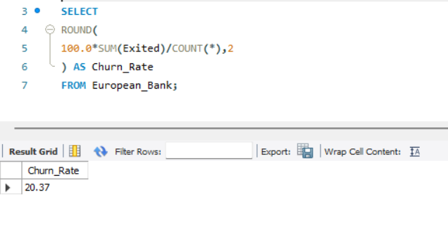
- Churn by Product Count
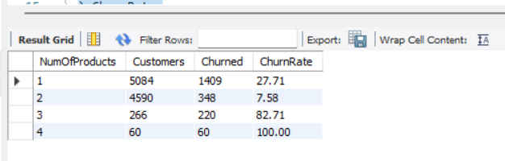
- Active vs Inactive Customer Analysis
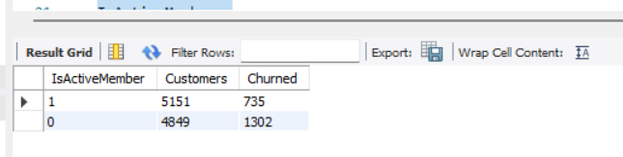

- Geography-wise Churn Analysis
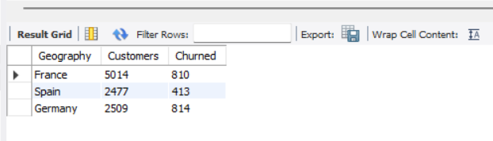
- High Balance Inactive Customer Identification
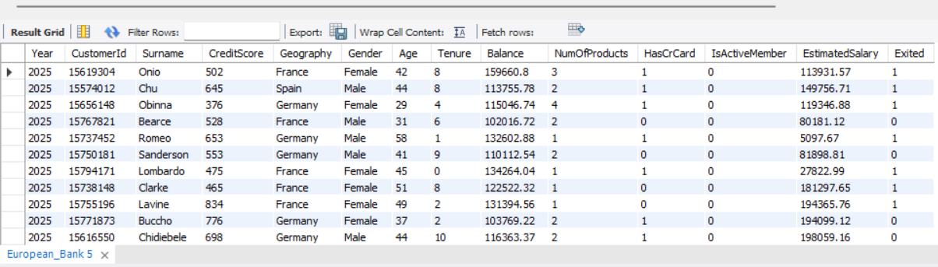
These queries helped identify customer groups requiring retention interventions.

8. Power BI Dashboard
An interactive dashboard was developed using Microsoft Power BI.

Page 1: Customer Churn Overview

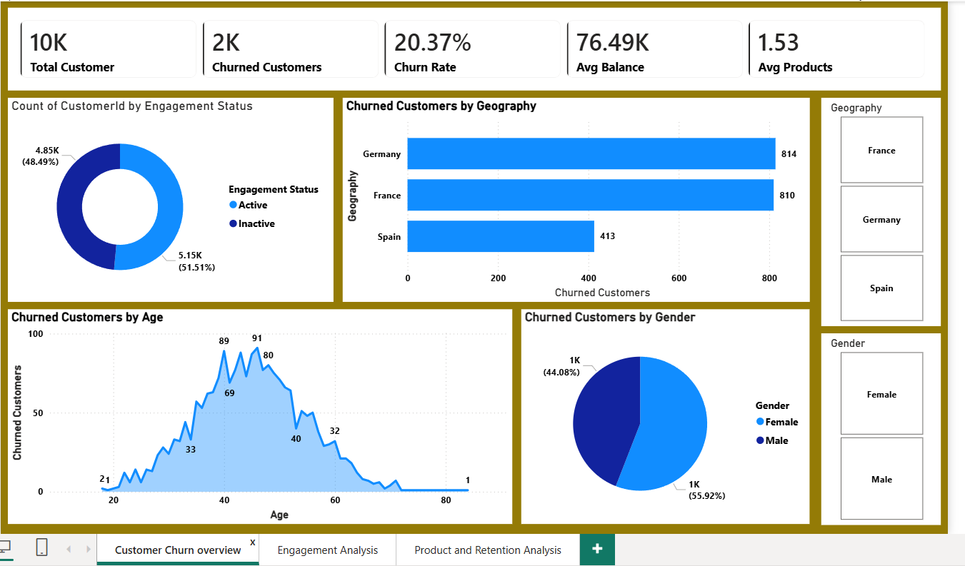

Page 2: Customer Engagement Analysis
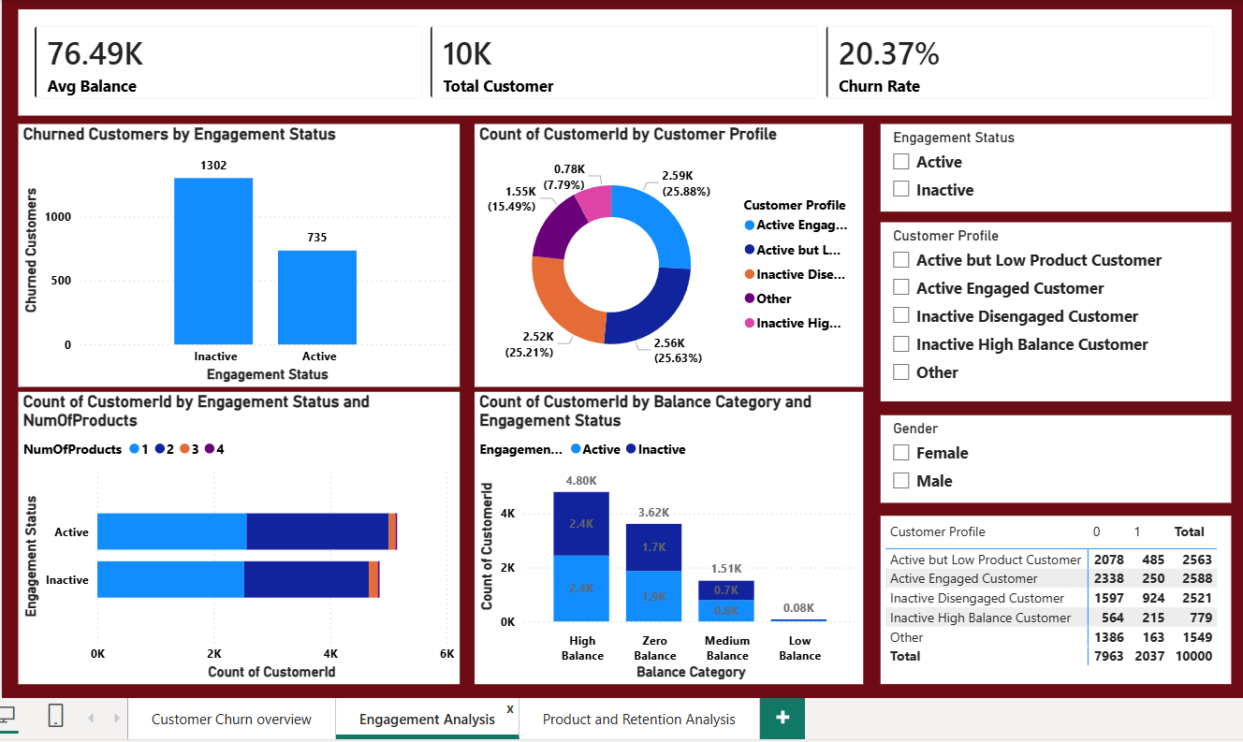

Page 3: Product Utilization & Retention Analysis
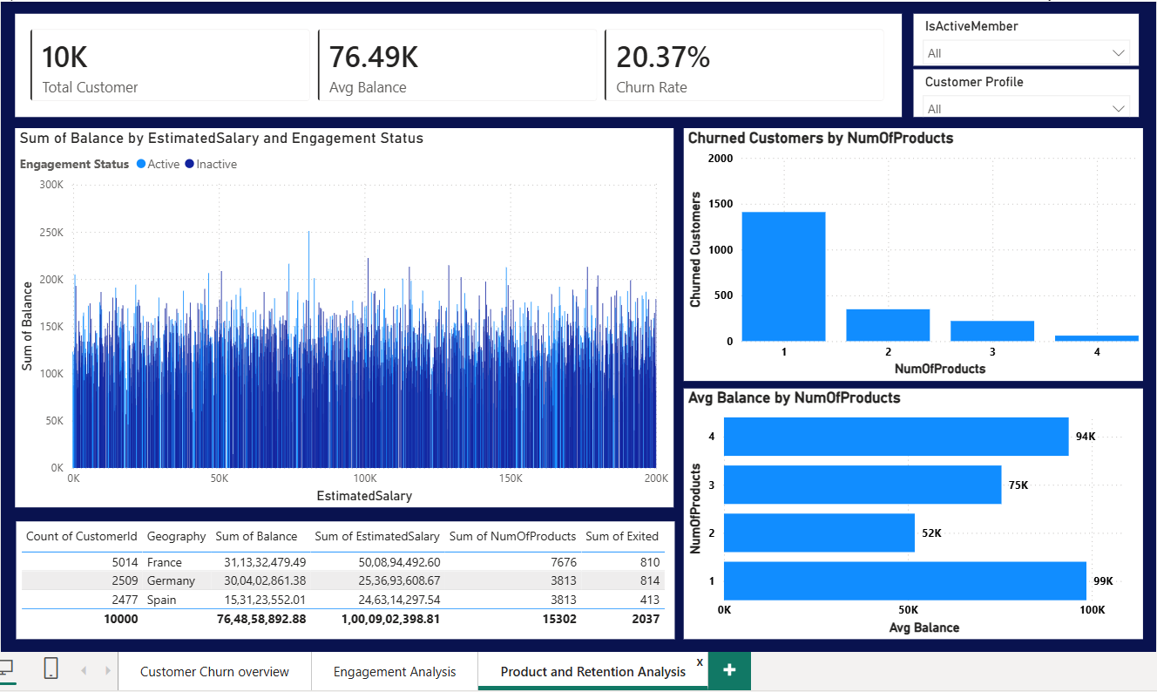

9. Key Insights
1. Over all churn rate is 20.37%. this is because out of 10,000 customers , 2037 customers have churned.
2.1302 churned customers belong to inactive customer profile and 735 churned customers belong to active customer profile.
3. Customers with single product show widest churned for approximately 1400.
4. Germany recorded the widest number of churned customers i.e 814. France closely followed with 810 churned customers. Spain reported the lowest churn count with 413.
5.Female customers contributed approximately 56% of total churn , while male customers contributed around 44%.
6. Inactive disengaged customers (2521 customers) represent high-risk segment requiring retention efforts.
7. Inactive high balance customers (779 customers) represent valuable customers who are at risk despite maintaining substantial balances.
8. Customers with 4 products maintain the highest average balance.
9. Customers with only 1 product have lower engagement and significantly higher churn indicating opportunities for cross selling additional banking products.

10. Recommendations
1.Increase customer engagement programmes by developing personalised communication campaigns targeting inactive customers.
2. Encourage the single-product-customers to adopt additional products.
3. Since Germany and France contribute the high churn volumes, region- specific retention strategies should be introduced. To identify market-specific issues through customer feedback analysis should be conducted.
4. More focus on high value with high account balance customers by implementing retention programs and by offering personalised financial consultations and loyalty incentives to prevent churn.
5. Improve customer experience by enhancing digital banking services , complaint resolution process and customer support responsiveness.

11. Conclusion
This project successfully analysed customer engagement, product utilization, and retention behaviour. The analysis revealed that customer engagement and product ownership are key factors influencing churn. Inactive customers and single-product customers were found to have the highest risk of leaving the bank. Additionally, Germany and France recorded the largest number of churned customers.
The study also identified a valuable segment of inactive high-balance customers who require immediate retention efforts. By implementing targeted engagement programs, promoting product cross-selling, and focusing on high-risk customer segments, the bank can significantly improve customer retention, reduce churn, and enhance long-term profitability. Dashboard provides a comprehensive decision-support tool that enables management to monitor customer behaviour and make data-driven strategic decisions.

